**Guidelines for JDBC Application Project in Netbeans 12.0 ©2020NorleyzaJailani**

1. **Setting up database**

If you have downloaded from <https://mirror.csclub.uwaterloo.ca/apache/db/derby/db-derby-10.14.2.0/> or from apache. I am using this version.

Select Services Tab in Netbeans

Right-click on Java DB, then click Start Server.

Right-click on Java DB, then click Properties and specify the locations of the following:

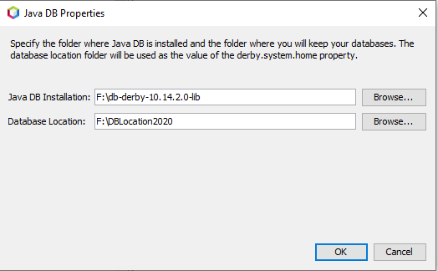

1. **Create Database**

Right-click on Java DB, click Create Database. NOTE: you must remember password. For lab exercise/labtest, please use the same username and password.

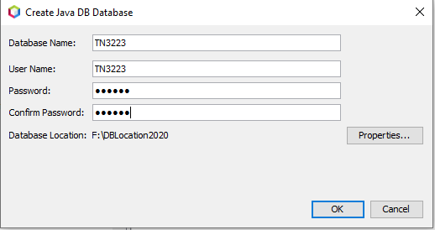

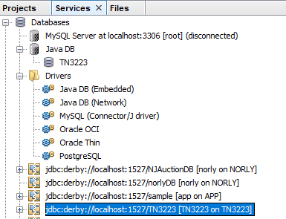

Note the highlighted database created named TN3223 (username and password TN3223) or any other name of your choice

TN3223 folder is created as well in the database location specified earlier

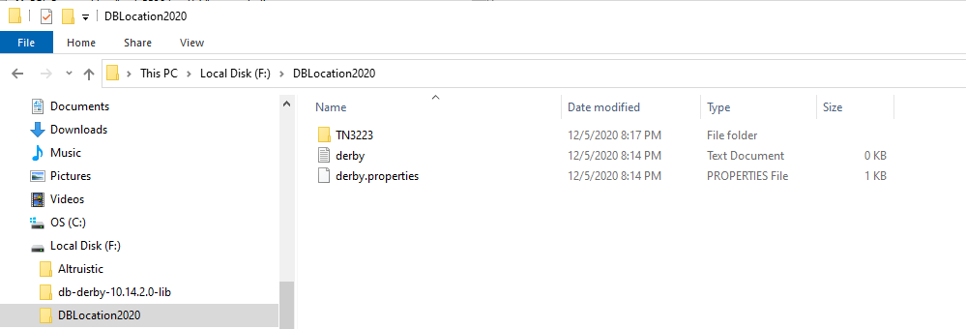

Right-click on the jdbc:derby://localhost:1527/TN3223 and click Connect

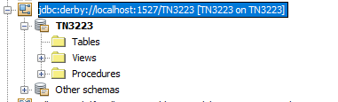

1. **Create Table**

Right-click on Tables and click create table Coffee

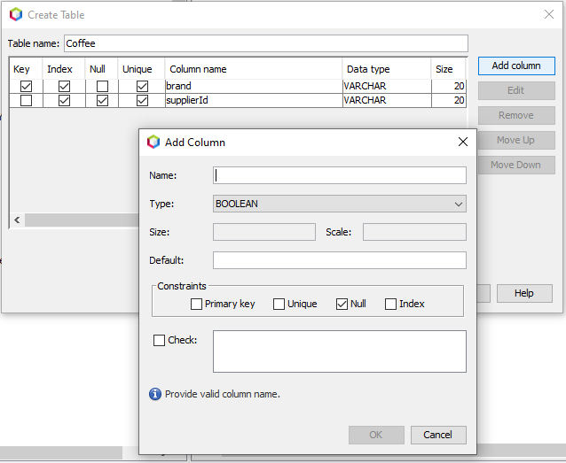

Add column

**brand**, varchar, size 20, primary and unique

**supplierId**, varchar, size 20, unique

**price**, double

**sales**, integer

**totalSales**, double

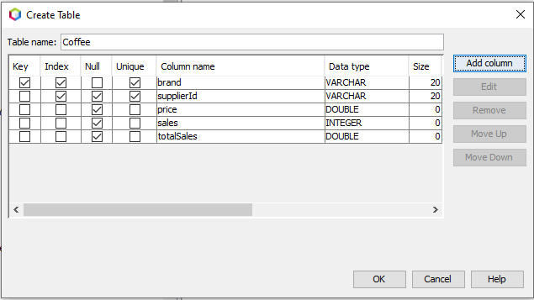

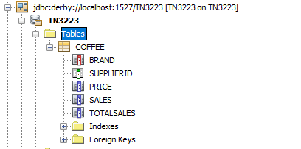

Right-click on table COFFEE and click view data

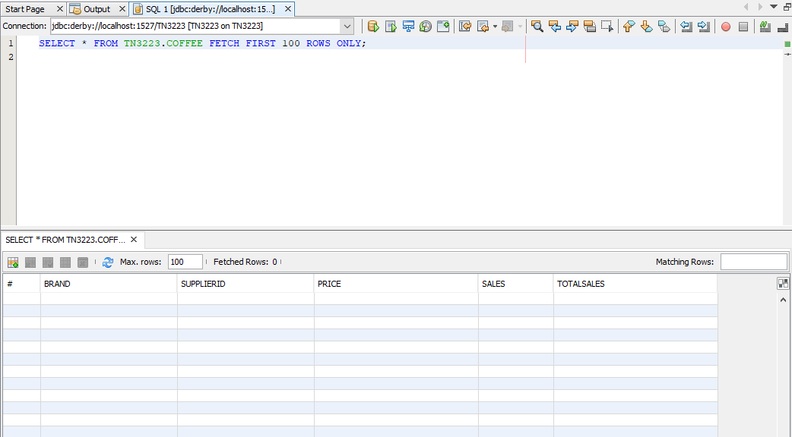

1. **Create Application**

Create New Project CoffeeDBApp, and then create New Java Class - CoffeeApp

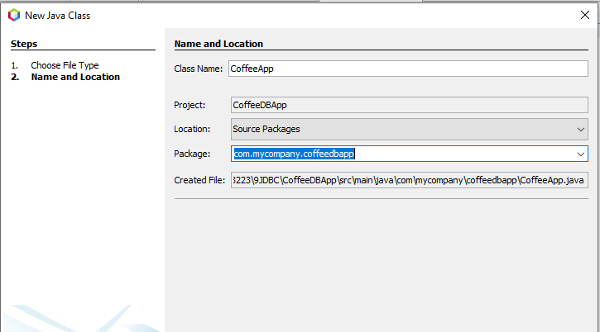

Copy content of file given and paste into CoffeeApp.java program

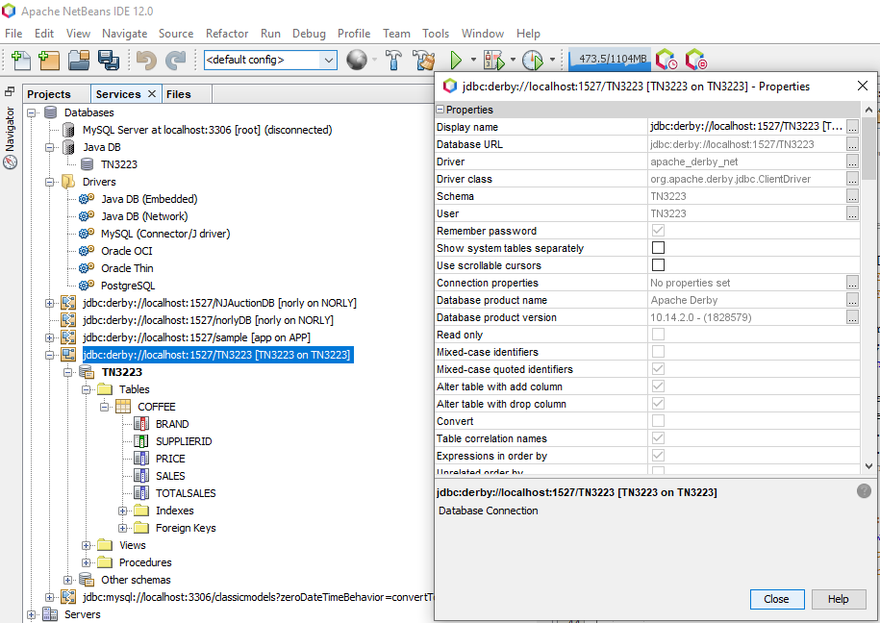

Based on your database and table name, modify the following lines:

final String query1 = "INSERT INTO TN3223.COFFEE VALUES(?, ?, ?, ?, ?)";

final String query2 = "SELECT * FROM TN3223.COFFEE";

String dbURL = "jdbc:derby://localhost:1527/TN3223";

properties.put("user", "TN3223");

properties.put("password", "TN3223");

1. **Connecting Project to JDBC**
2. Adding Depencencies

(in older Netbeans add derbyclient.jar into project library)

Right-click on Dependencies and click Add Dependency with the following entries

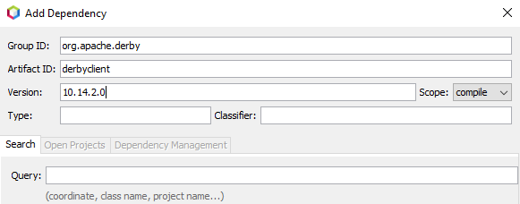

Note that derbyclient-10.14.2.0.jar is added under Dependencies folder as well as in pom.xml

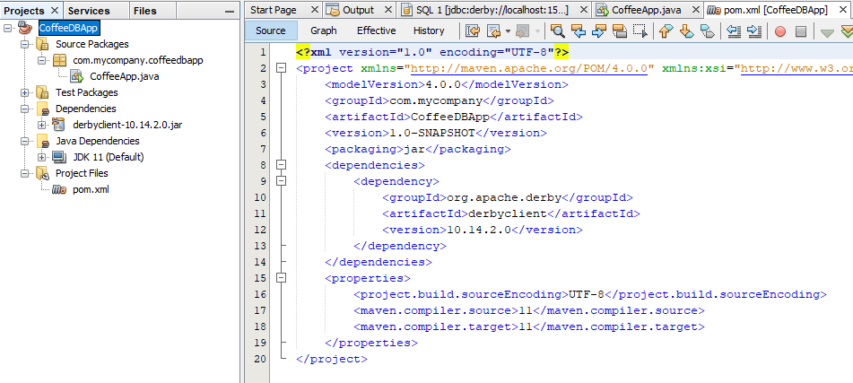

1. Adding jar files to classpath

You have to place appropriate jar file to the classpath (Control panel>System>Advanced System Setting>Environment Variables, under System, select classpath and add the following:

derby.jar: for embedded driver.

derbyclient.jar: for network client driver.

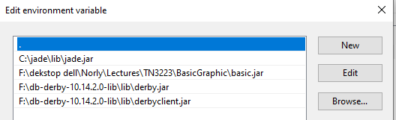

[https://www.codejava.net/java-se/jdbc](https://www.codejava.net/java-se/jdbc/jdbc-driver-library-download) (for other database type dependencies). Also a good site for tutorials on jdbc.

1. **Clean and build project and run the program**

Right-click CoffeeApp.java and run

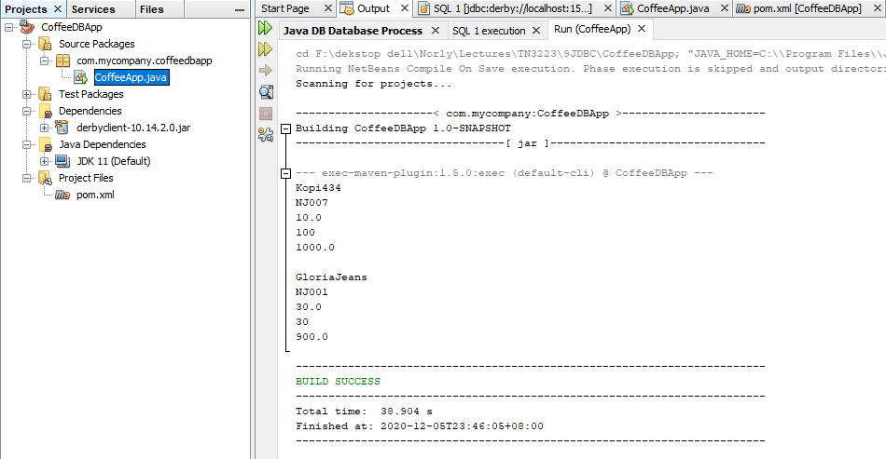

Right-click table Coffee and click View Data (or refresh)

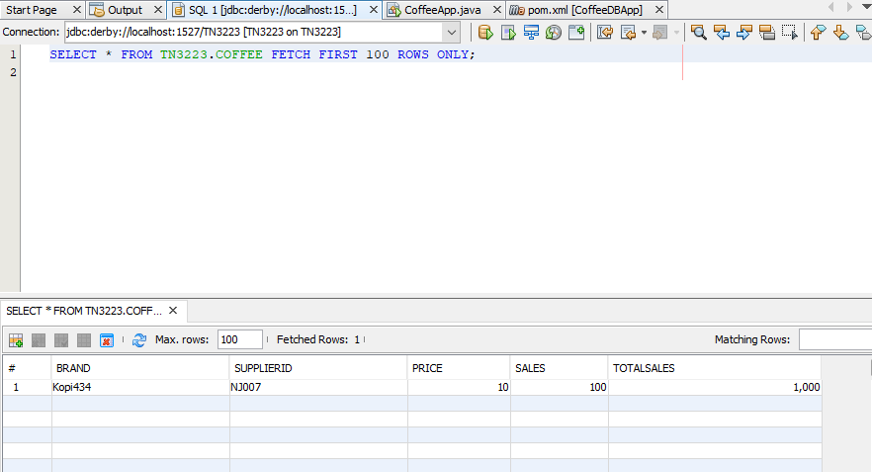

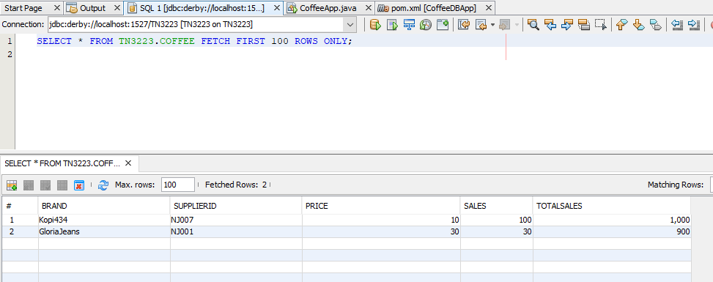

Since brand and supplierId were specified as unique, you cannot enter the same value twice.